**Build CI/CD in AWS using Code Pipeline and Code Build**

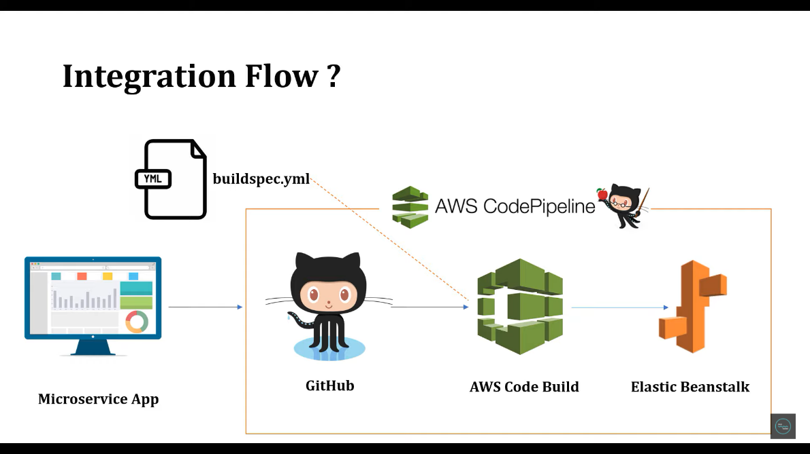**1.Flow**

**2.go to POM file and add the jar name as filename tag**

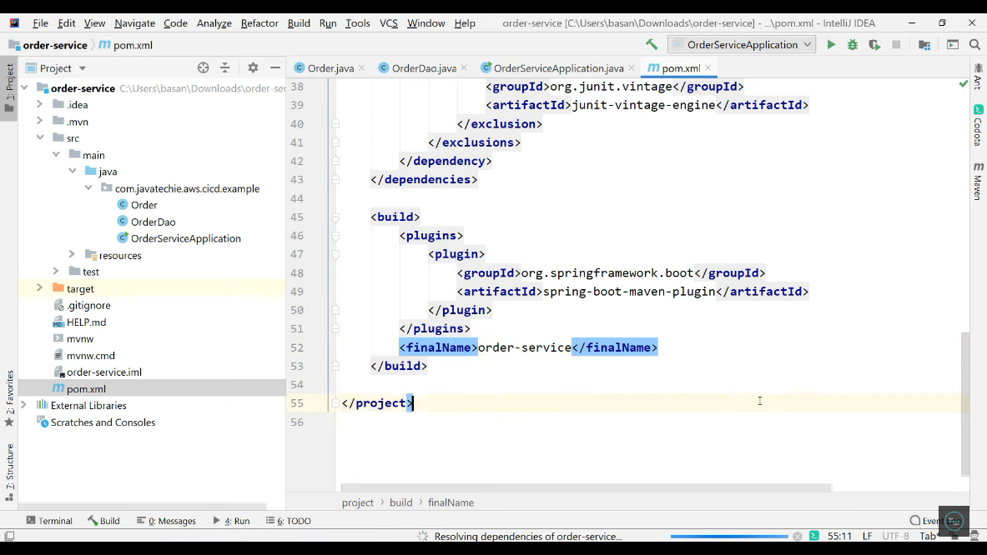

**3.add Pom.xml and src to git repository you have created**

**4.create a file name as buildspec.yml in root folder eg. order-service**

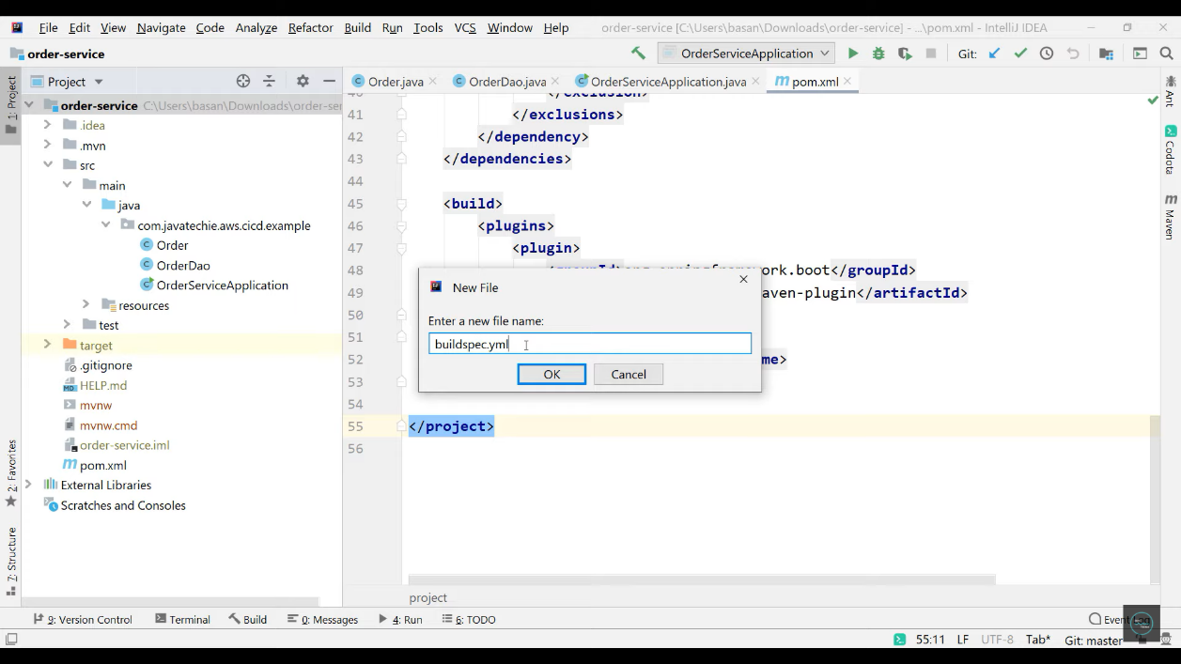

**5.add the given provided data into build spec file**

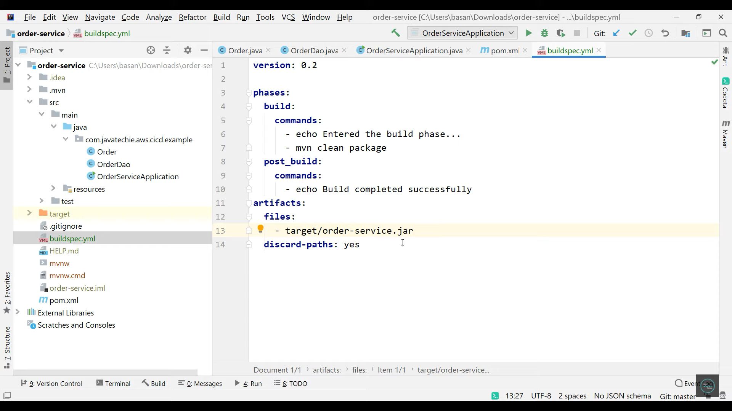

**6.Create a new Elastic Beanstalk Environment and add domain, platform and click on create Environment.**

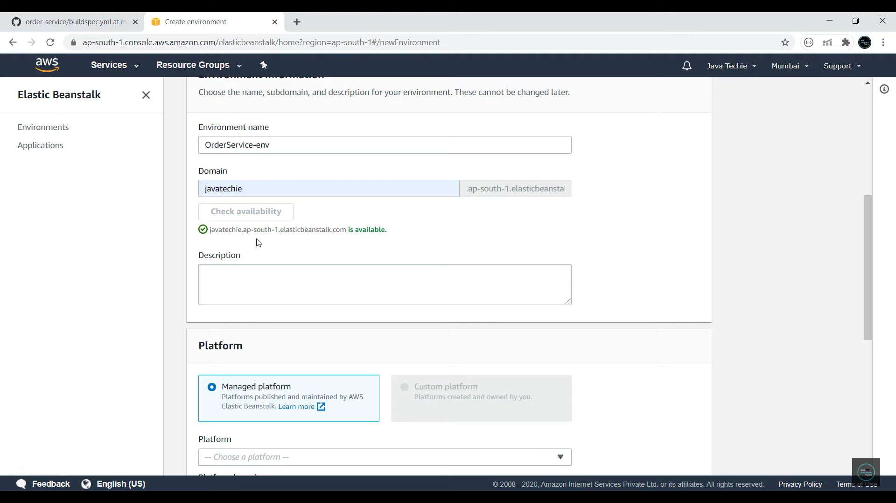

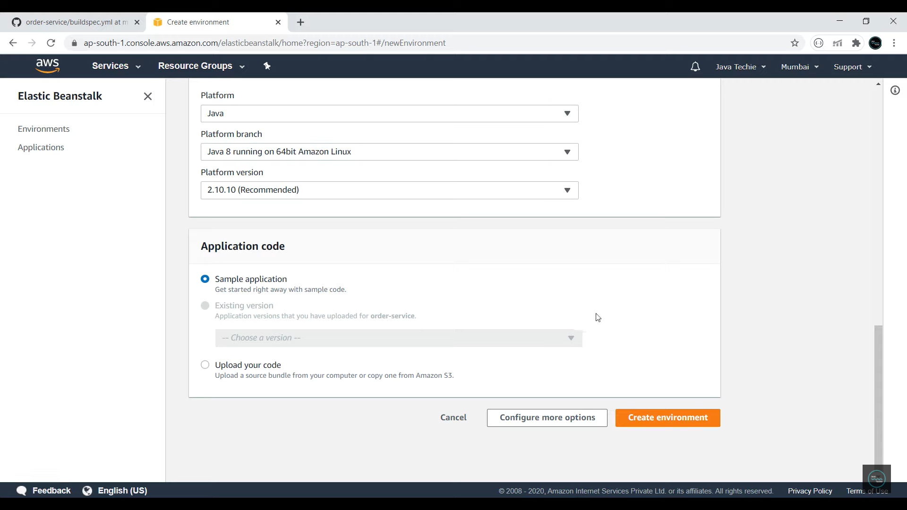

**7.Create a new pipeline in AWS so that we can get data from the github and it automatically build it.go to aws.amazon.com/console/**

**8.Ceate a new pipeline by writing code Pipeline in find services.**

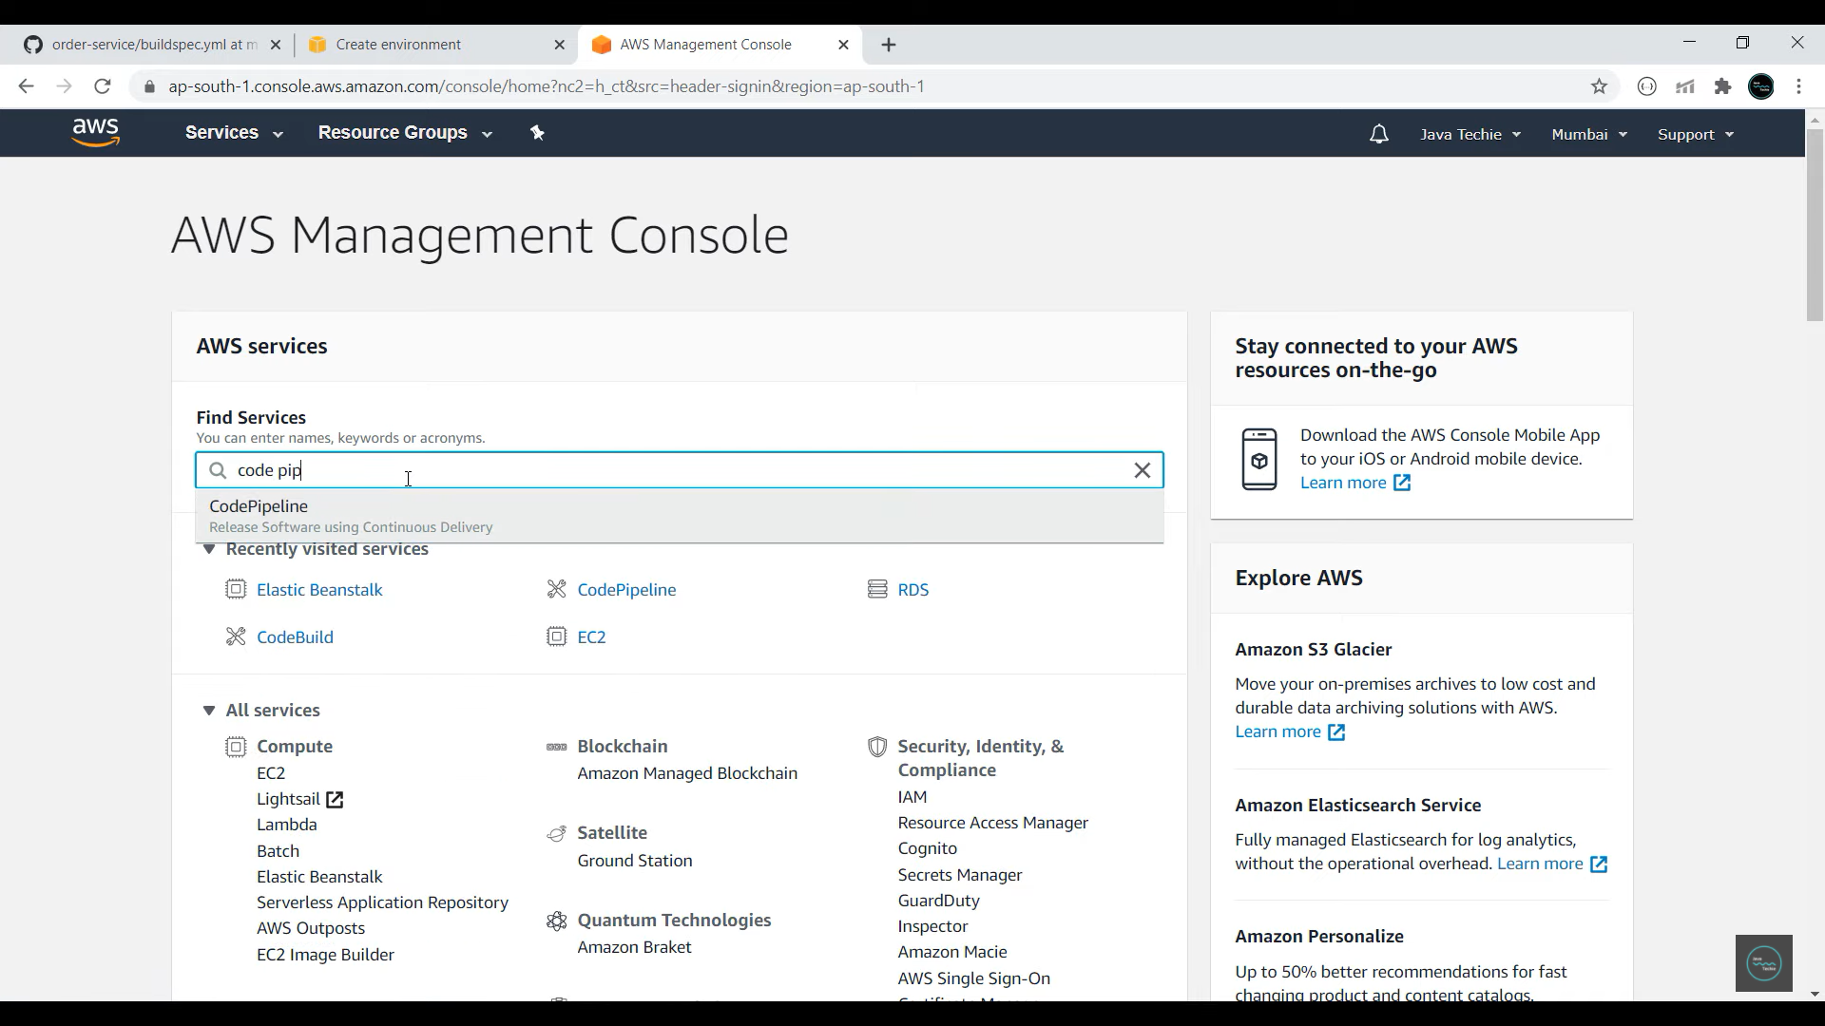

**9.In source provider write GitHub and connect your GitHub Repo.**

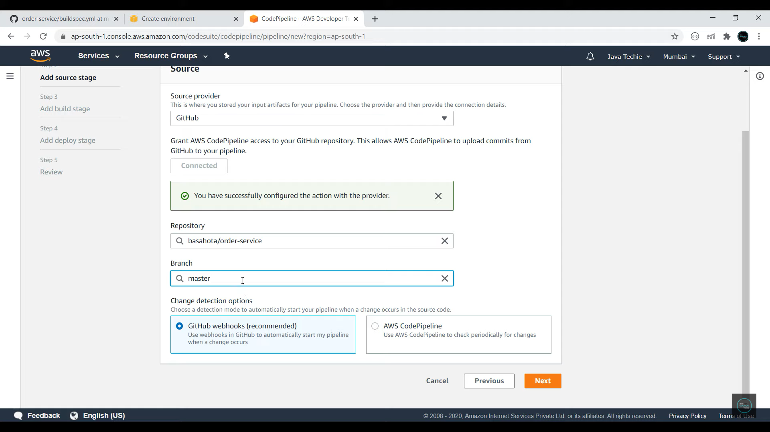

**Review before creating pipeline**

